MANUFACTURING ENTITY OF THE YEAR
Name of Construction Entity:

Grade:

Cidb Registration No.:
Key contact person:

Full Name:

Date of Entry Completion:

Address:

Contact Person:

Telephone No:

Email:
Approval by head/owner of Entity:

Full Name:

Contact Person:

Telephone No:

Email:

Signature:
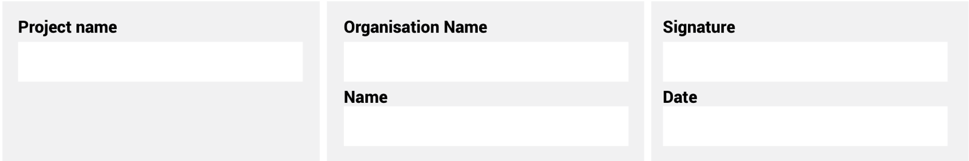
The information supplied is correct and has been approved by the ENTRANT entity

ENTRY CRITERIA
CATEGORY 9
Manufacturing Entity of the Year
The second of the new categories for 2024 aims to recognize the Manufacturing entities supplying the construction sector and their continued impact on women in the industry through employment strategies, empowerment programmes and significant transformation.

REQUIREMENTS FOR SUBMISSION | SCORECARD
- Provide valid CIPC document of ownership. | 5
- Provide valid BBBEE certificate. | 5
- Provide evidence of systems in place to ensure a continued quality product. | 10
- Clearly provide examples of adherence to quality standards and product quality, including certificates from a 3rd party such as SABS or other standards authorities. | 20
- Clearly detail evidence of the reliance on local supplies in the manufacturing process and the contribution to local communities. | 15
- Provide an overview of the systems and procedures for manufacture and supply of goods. | 20
- Describe leadership positions of women in the entity in a diagrammatic format. | 5
- Describe, in no more than two pages, how the entity has strived to uplift women in their environment. | 15
- Provide a 100-word executive summary of the entry for publication and presentation use. | 5
Total: | 100
At least five high-resolution (min 1MB) photographs of the construction entity and/or project in jpeg format must be included.
A high-resolution (min 1MB) logo in jpeg format must also be included.
NB: If any of the above documents are not included in your entry submission please indicate when they will be provided.

