PROFESSIONAL TEAM OF THE YEAR

Name of Construction Entity:

Key contact person:

Full Name:

Date of Entry Completion:

Address:

Contact Person:

Telephone No:

Email:
Approval by head/owner of Entity:

Full Name:

Contact Person:

Telephone No:

Email:

Signature:
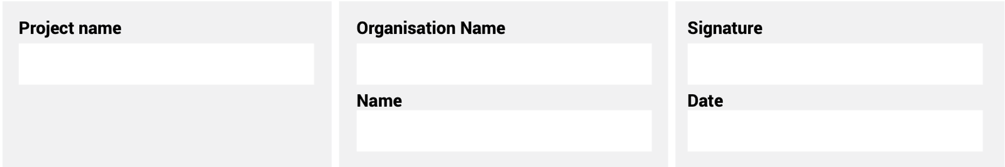
The information supplied is correct and has been approved by the ENTRANT entity

ENTRY CRITERIA
CATEGORY 8
Professional Team of the Year
This award aims to recognise the professional project team – led by a woman – that has completed a project within the client brief. The team will have demonstrated overall excellence in project implementation, met the client’s requirements and have been led by an effective women project team leader. Project criteria include sustainability and the provision of innovative solutions for the client.
REQUIREMENTS FOR SUBMISSION | SCORECARD
- Provide valid CIPC document of ownership. | 5
- Provide valid BBBEE certificate. | 5
- Provide one page overview of entity and 100-word CV of the key personnel on the project, in diagrammatic format. | 10
- Provide proof of membership of relevant industry bodies. | 5
- Provide Project Implementation Plan. | 10
- Provide Certificate of Completion by client. | 5
- Provide valid Occupational Health and Safety Audit document. | 5
- Provide final Health and Safety Audit document. | 5
- Provide evidence of the involvement and empowerment of women in the project. | 10
- Provide evidence of innovation and sustainability in the project. | 10
- Include an acknowledgement from the key client. | 10
- Describe any innovation and sustainable solutions provided for the project. | 10
- Provide a 100-word executive summary of the entry for publication and presentation use. | 10
Total: | 100
At least five high-resolution (min 1MB) photographs of the construction entity and/or project in jpeg format must be included.
A high-resolution (min 1MB) logo in jpeg format must also be included.
NB: If any of the above documents are not included in your entry submission please indicate when they will be delivered.

