INNOVATIVE ENTITY OF THE YEAR
Name of Construction Entity:

Grade:

Cidb Registration No.:
Key contact person:

Full Name:

Date of Entry Completion:

Address:

Contact Person:

Telephone No:

Email:
Approval by head/owner of Entity:

Full Name:

Contact Person:

Telephone No:

Email:

Signature:
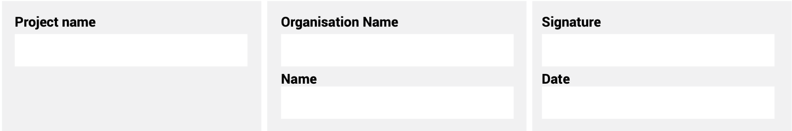
The information supplied is correct and has been approved by the ENTRANT entity

ENTRY CRITERIA
CATEGORY 7
Innovative Entity of the Year
This award aims to recognise the entity utilising new technologies and showing innovation in
their approach to projects and/or their business. Technological advances can lead to significant transformation in ways in which infrastructure is planned, procured, delivered and maintained.
The Award will recognise those entities bravely adopting these technologies.

REQUIREMENTS FOR SUBMISSION | SCORECARD
- Provide valid CIPC document of ownership. | 10
- Provide valid BBBEE Certificate. | 5
- Evidence of the use of the advances of fourth industrial revolution (4IR) into their construction projects. Entrant to provide evidence of the use of 4IR advances that are currently deployed in the construction industry, such as:  - Building Information Modelling for design purposes.  - Use of additive technology (3D printing) of construction models drawn from professional and 3D practitioners.  - Alternative building Technologies (ABT) used mostly in human settlements for fast delivery of housing stock –drawn from designers and manufactures of construction panels, as well as installers.  - Software technology used in infrastructure design and collaborations across geographic locations, e.g. BIM.  - 3D modelling that helps designers and building owners by showing how a built structure will look.  - Use of robotics which is used to increase productivity and access areas of the construction projects that may be unsafe for humans to work in, thereby improving industry health and safety practices.  - Use of drones that are used to provide progress reports, reducing the cost of time and travel for key project management personnel. | 85
Total: | 100
At least five high-resolution (min 1MB) photographs of the construction entity and/or project in jpeg format must be included.
A high-resolution (min 1MB) logo in jpeg format must also be included.
NB: If any of the above documents are not included in your entry submission please indicate when they will be delivered.

