TRANSFORMATION ENTITY OF THE YEAR
Name of Construction Entity:

Grade:

Cidb Registration No.:
Key contact person:

Full Name:

Date of Entry Completion:

Address:

Contact Person:

Telephone No:

Email:
Approval by head/owner of Entity:

Full Name:

Contact Person:

Telephone No:

Email:

Signature:
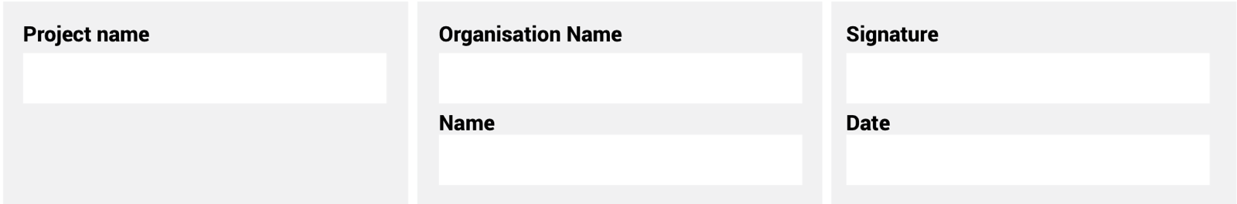
The information supplied is correct and has been approved by the ENTRANT entity

ENTRY CRITERIA
CATEGORY 6
Transformation Entity of the Year
This award is to highlight that the entity has supported and continues to support their women employees and nurtures talent in a way that has helped them to grow and mature within their fields. The entity must display support of the gender agenda through the implementation of a transformation policy to enhance the sustainability of women.

REQUIREMENTS FOR SUBMISSION | SCORECARD
- Provide valid CIPC document of ownership. | 5
- Provide valid BBBEE Certificate. | 5
- Provide evidence of the contribution this entity is making to the upliftment of women in the industry. | 20
- Provide evidence of the leadership position of women in the organisation in diagrammatic format. | 20
- Clearly demonstrate the contribution this entity is making to women empowerment in the construction industry. | 5
- Describe the process of transformation and provide examples. | 5
- Provide evidence of a formal adherence to the Gender Agenda. | 10
- Provide timeline examples of employees/staff that have experienced transformation. | 10
- Describe, in no more than two pages, how the entity has empowered and transformed the role of women in the industry. | 10
- Provide a 100-word executive summary of the entry for publication and presentation use. | 10
Total: | 100
At least five high-resolution (min 1MB) photographs of the construction entity and/or project in jpeg format must be included.
A high-resolution (min 1MB) logo in jpeg format must also be included.
NB: If any of the above documents are not included in your entry submission please indicate when they will be delivered.

