MENTORING ENTITY OF THE YEAR

Name of Construction Entity:

Grade:
Key contact person:

Full Name:

Date of Entry Completion:

Address:

Contact Person:

Telephone No:

Email:
Approval by head/owner of Entity:

Full Name:

Contact Person:

Telephone No:

Email:

Signature:
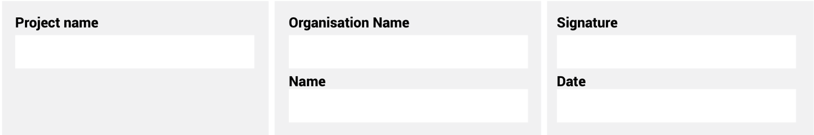
The information supplied is correct and has been approved by the ENTRANT entity

ENTRY CRITERIA

CATEGORY 5
Mentoring Entity of the Year
This category awards an entity within the construction industry that is positively contributing
to the development and support of women in the construction industry. The entity is
providing skills-based training, formal mentorship programmes and on the
job support for women in the organisation.

REQUIREMENTS FOR SUBMISSION | SCORECARD
- Provide valid CIPC document of ownership. | 5
- Provide valid BBBEE Certificate. | 5
- Provide evidence of the contribution this entity is making to women in their environment. | 15
- Clearly detail the entity’s formal women mentorship programme/s. | 10
- Clearly detail the entity’s formal skills-based programme/s for women. | 10
- Clearly detail the entity’s formal training programme/s for women. | 10
- Describe the process of mentorship and provide examples. | 20
- Describe, in no more than two pages, how the entity has mentored women in their environment. | 20
- Provide a 100-word executive summary of the entry for publication and presentation use. | 5
Total: | 100
At least five high-resolution (min 1MB) photographs of the construction entity and/or project in jpeg format must be included.
A high-resolution (min 1MB) logo in jpeg format must also be included.
NB: If any of the above documents are not included in your entry submission please indicate when they will be delivered.

