INTERIOR DESIGN AND BUILD PROJECT OF THE YEAR
Name of Construction Entity:

Grade:

Name of Project:

Cidb Registration No.:
Key contact person:

Full Name:

Date of Entry Completion:

Address:

Contact Person:

Telephone No:

Email:
Approval by head/owner of Entity:

Full Name:

Contact Person:

Telephone No:

Email:

Signature:
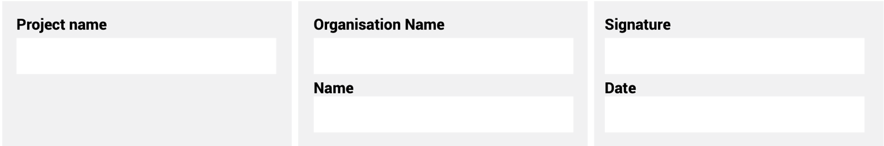
The information supplied is correct and has been approved by the ENTRANT entity

ENTRY CRITERIA

CATEGORY 3
Interior Design and Build Project of the Year
This category provides a platform to highlight the expertise, creativity, and project management skills of women professionals in this specialised field. Interior Design and Build Project of the Year will honour the achievements of women in interior construction.
REQUIREMENTS FOR SUBMISSION | SCORECARD
- Provide valid BBBEE Certificate. | 10
- Provide one page overview of entity and 100-word CV of the key personnel on the project. | 10
- Provide Project Implementation Plan. | 15
- Provide Certificate of Completion by client. | 10
- Provide evidence of the involvement and empowerment of women in the project. | 15
- Include an acknowledgement from the key client. | 10
- Describe any innovation and sustainable solutions provided for the project, as well as a demonstration of diversity, equity and inclusion (DEI) in delivery. | 25
Total: | 100
At least five high-resolution (min 1MB) photographs of the construction entity and/or project in jpeg format must be included.
A high-resolution (min 1MB) logo in jpeg format must also be included.
NB: If any of the above documents are not included in your entry submission please indicate when they will be provided.

