RURAL PROJECT OF THE YEAR
Name of Construction Entity:

Grade:

Name of Project:

Cidb Registration No.:
Key contact person:

Full Name:

Date of Entry Completion:

Address:

Contact Person:

Telephone No:

Email:
Approval by head/owner of Entity:

Full Name:

Contact Person:

Telephone No:

Email:

Signature:
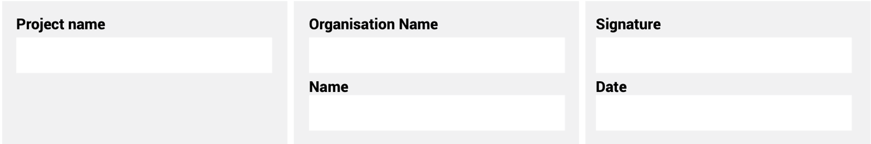
The information supplied is correct and has been approved by the ENTRANT entity

ENTRY CRITERIA

CATEGORY 2
Rural Project of the Year
This category recognises women-owned construction entities who have motivated and completed a successful project within the rural environment.
REQUIREMENTS FOR SUBMISSION | SCORECARD
- Provide valid CIPC document of ownership. | 5
- Provide valid BBBEE Certificate. | 5
- Provide one page overview of entity and 100-word CV of the key personnel on the project. | 5
- Provide Project Implementation Plan. | 15
- Provide Certificate of Completion by client. | 5
- Provide valid Occupational Health and Safety document. | 5
- Provide final Health and Safety audit document. | 5
- Clearly outline any challenges in managing this rural project and the successful outcomes, including any direct community involvement. | 15
- Clearly demonstrate the involvement of women in the project and the impact on the rural community. | 15
- Include an acknowledgement from the client. | 5
- Describe the contractor’s innovation, sustainability and contribution to the industry aimed at the upliftment of the rural society / community. | 10
- Describe, in no more than two pages, how the contractor has empowered women in the area during this project. | 5
- Provide a 100-word executive summary of the entry for publication and presentation use. | 5
Total: | 100
At least five high-resolution (min 1MB) photographs of the construction entity and/or project in jpeg format must be included.
A high-resolution (min 1MB) logo in jpeg format must also be included.
NB: If any of the above documents are not included in your entry submission please indicate when they will be delivered.

