EXCEPTIONAL WOMAN IN CONSTRUCTION CONTRIBUTOR OF THE YEAR

Name of Construction Entity:

Key contact person:

Full Name:

Date of Entry Completion:

Address:

Contact Person:

Telephone No:

Email:
Approval by head/owner of Entity:

Full Name:

Contact Person:

Telephone No:

Email:

Signature:
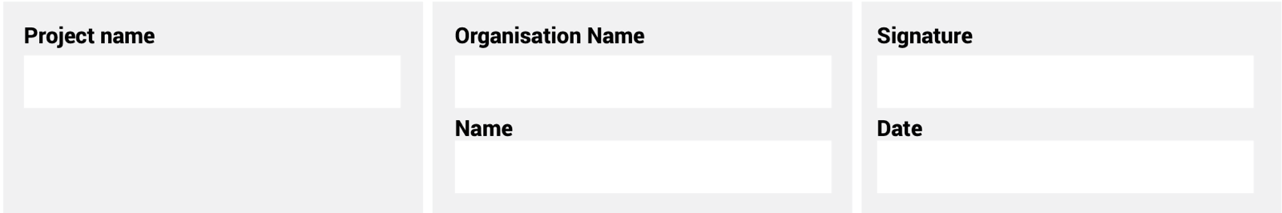
The information supplied is correct and has been approved by the ENTRANT entity

ENTRY CRITERIA

CATEGORY 14
Exceptional Woman in Construction Contributor of the Year
This award is to reward a woman working within any sector of the construction industry who is professional, ethical and committed. The recipient shows determination and skill to advance within her field and at the same time promoting and highlighting the contribution by women in the industry.
REQUIREMENTS FOR SUBMISSION | SCORECARD
- The nomination must include a motivation detailing the outstanding achievements of the nominee relevant to the construction industry covering the following areas:
- Educational achievements (where applicable).  - Practical achievements.  - Recognition of awards received (if any). | 50
- Provide 100-word executive summary of the entry for publication and presentation use. | 50
Total: | 100
At least five high-resolution (min 1MB) photographs of the construction entity and/or project in jpeg format must be included.
A high-resolution (min 1MB) logo in jpeg format must also be included.
NB: If any of the above documents are not included in your entry submission please indicate when they will be delivered.

