WOMAN MENTOR OF THE YEAR

Name of Construction Entity:

Key contact person:

Full Name:

Date of Entry Completion:

Address:

Contact Person:

Telephone No:

Email:
Approval by head/owner of Entity:

Full Name:

Contact Person:

Telephone No:

Email:

Signature:
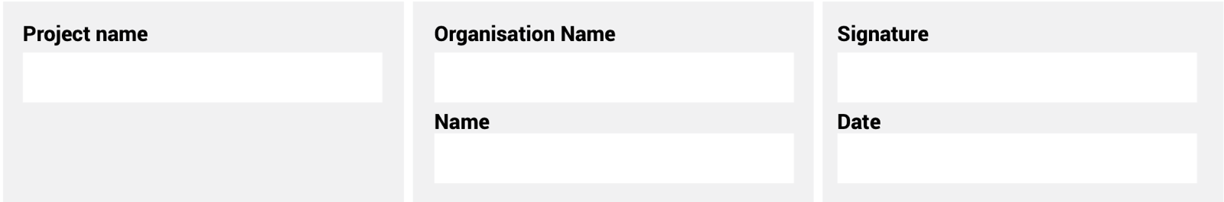
The information supplied is correct and has been approved by the ENTRANT entity

ENTRY CRITERIA
CATEGORY 12
Woman Mentor of the Year
This award is to recognise the women who have supported and continue to support other women working within the construction industry, who have contributed to nurturing talent in a way that has helped them to grow and mature within their fields.

REQUIREMENTS FOR SUBMISSION | SCORECARD
- Provide evidence of the entrant’s mentorship of other women in the industry. | 10
- The nomination must include a motivation detailing the outstanding achievements of the nominee relevant to the construction industry covering the following areas:
- Educational achievements (where applicable).  - Practical achievements.  - Recognition of awards received (if any). | 10
- Evidence of innovative contributions to the industry. | 15
- Evidence of her ability to nurture and support other women in the industry. | 10
- Highlight personal and professional barriers that have been overcome. | 20
- Evidence of continued support and transformation of women in the industry. | 20
- Leadership ability of the nominee and her contribution to building the image of the construction industry in general. | 10
- Provide a 100-word executive summary of the entry for publication and presentation use. | 5
Total: | 100
At least five high-resolution (min 1MB) photographs of the construction entity and/or project in jpeg format must be included.
A high-resolution (min 1MB) logo in jpeg format must also be included.
NB: If any of the above documents are not included in your entry submission please indicate when they will be delivered.

