WOMAN-OWNED CONSTRUCTION ENTITY OF THE YEAR
Name of Construction Entity:

Grade:

Cidb Registration No.:
Key contact person:

Full Name:

Date of Entry Completion:

Address:

Contact Person:

Telephone No:

Email:
Approval by head/owner of Entity:

Full Name:

Contact Person:

Telephone No:

Email:

Signature:
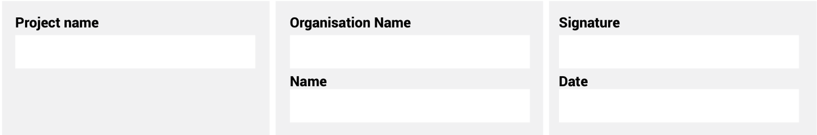
The information supplied is correct and has been approved by the ENTRANT entity

ENTRY CRITERIA

CATEGORY 11
Woman-owned Construction Entity of the Year
This award aims to recognise a key woman player with 51% or more ownership of a construction entity. The individual has managed and grown a successful entity in the industry. The individual has contributed significantly to the development of the South African construction industry, through her dedication, conviction, vision, commitment and leadership.
REQUIREMENTS FOR SUBMISSION | SCORECARD
- Provide valid CIPC document of ownership. | 5
- Provide valid BBBEE Certificate. | 5
- The nomination must include a motivation detailing the outstanding achievements of the nominee relevant to the construction industry covering the following areas:
- Educational achievements (where applicable).  - Practical achievements.  - Recognition of awards received (if any). | 10
- Evidence of innovative contributions to the industry. | 5
- Highlight personal and professional barriers that have been overcome. | 20
- Evidence of continued professional development. | 20
- Leadership ability of the nominee and her contribution to building the image of the construction industry in general. | 20
- Provide 100-word executive summary of the entry for publication and presentation use. | 15
Total: | 100
At least five high-resolution (min 1MB) photographs of the construction entity and/or project in jpeg format must be included.
A high-resolution (min 1MB) logo in jpeg format must also be included.
NB: If any of the above documents are not included in your entry submission please indicate when they will be delivered.

