YOUTH-OWNED WOMAN CONSTRUCTION ENTITY OF THE YEAR
Name of Construction Entity:

Grade:

Name of Project:

Cidb Registration No.:
Key contact person:

Full Name:

Date of Entry Completion:

Address:

Contact Person:

Telephone No:

Email:
Approval by head/owner of Entity:

Full Name:

Contact Person:

Telephone No:

Email:

Signature:
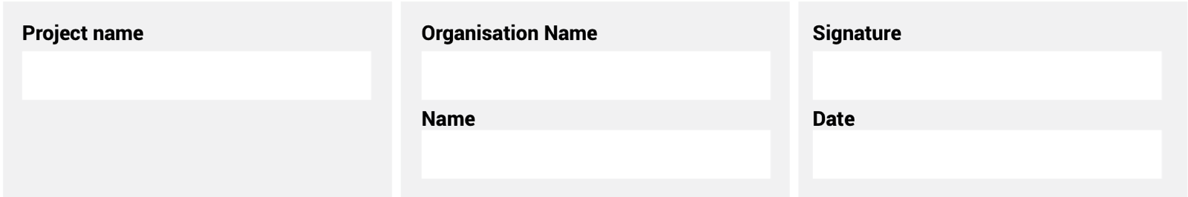
The information supplied is correct and has been approved by the ENTRANT entity

ENTRY CRITERIA

CATEGORY 10
Youth-owned Woman Construction Entity of the Year
This category recognises an entity owned by a female aged 35 years or younger. The entity must be sustainable, display a good track record for over two years, and be contributing to the empowerment of women and the industry as a whole.
REQUIREMENTS FOR SUBMISSION | SCORECARD
- Provide valid CIPC document of ownership. | 5
- Provide valid BBBEE Certificate. | 5
- Provide Certified copy of the individual’s identity document. | 5
- Describe history of the entity – from inception to 2020. | 20
- Provide 100-word CV overview of each of the key personnel. | 20
- Provide evidence of the entity’s innovation, sustainability and contribution to the industry. | 20
- Describe, in no more than two pages, how the entity has empowered women in the industry. | 20
- Provide a 100-word executive summary of the entry for publication and presentation use. | 5
Total: | 100
At least five high-resolution (min 1MB) photographs of the construction entity and/or project in jpeg format must be included.
A high-resolution (min 1MB) logo in jpeg format must also be included.
NB: If any of the above documents are not included in your entry submission please indicate when they will be delivered.

